Retail Store Product Demand Prediction ( Phase 3 )
Abstract:
Supply
Problem Description: The main aim of our project is to develop a machine learning model (Decision Tree Regression, Random Forest Regression, Gradient Boosting Regression) that forecasts retail store product demand based on Location (Indian cities) and Season (Summer, Winter, Monsoon, Autumn).
3.1 Dataset Information:
The primary goal of this project is to create a predictive model that can estimate the demand for the product in the market under different pricing strategies. By analysing historical sales data, the project aims to identify the price point at which the product is perceived as a better deal compared to competitors, leading to increased sales.
- Data Collection: Historical sales data
Dataset Link: https://www.kaggle.com/datasets/chakradharmattapalli/product-demandprediction-with-machine-learning
- Data Pre-processing: Clean and pre-process the data, handle missing values, and convert categorical features into numerical representations
- Feature Engineering: Create additional features that capture seasonal patterns, trends, and external influences on product demand.
- Model Selection: Choose suitable regression algorithms (e.g., Decision Tree, Random Forest, Gradient Boost) for demand forecasting.
- Model Training: Train the selected model using the pre-processed data.
- Evaluation: Evaluate the model's performance using appropriate regression metrics (e.g., Mean Absolute Error, Root Mean Squared Error ,R Squared).

Dataset Columns:
The dataset provided for this task includes the following key information:
- Product ID: A unique identifier assigned to each row in the dataset.
- Store ID: Each store is assigned a unique numeric ID (e.g., 8091, 8095) to identify different retail outlets.
- Total Price: The actual selling price after discounts or promotions.
- Base Price: The original price before any discounts are applied.
- Units Sold (Quantity Demanded): The quantity purchased by customers at a given location and season. This is our target variable.
- Season: The season during which the sale occurred (Summer, Winter, Monsoon, Autumn).
- Location: The Indian city where the retail store is located (Mumbai, Delhi, Bangalore, Chennai, Kolkata, Hyderabad, Pune, Jaipur). This is a key feature for demand prediction.
- Product: The name of the product being sold (Rice, Cold Drinks, Umbrella, Sweater, Sunscreen, Raincoat, Ice Cream, Heater, Jacket, Water Bottle).
Training Data:
- Independent Variables (Features):
- Store ID
- Location
- Season
- Product
- Total Price
- Base Price.
- Dependent Variable (Target):
- Units Sold: The number of units of the product sold.
- During the training phase, the machine learning model uses Store ID, Location, Season, Product, Total Price, and Base Price as independent variables to predict the Units Sold.
3.2 Loading the dataset:
- Importing the datasets:
Import the dataset using a function in pandas called pd.read_csv.
- View of the dataset:

By using a special function called head(), we will be displaying the first 5 columns and if
mentioned any number(n) within the parentheses, then ‘n’ rows of data will be printed.

data.head()
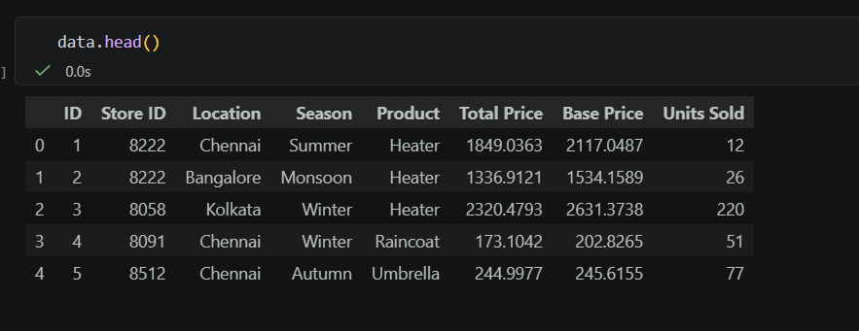
- Shape of a dataset:

The shape of the dataset is basically a representation of total rows and columns present in
the dataset.
data.shape


- Descriptive statistics of the data-sets:

In pandas, describe() function is used to view central tendency, mean, median, standard
deviation, percentile & many other things to give you the idea about the data.

data.describe().transpose()

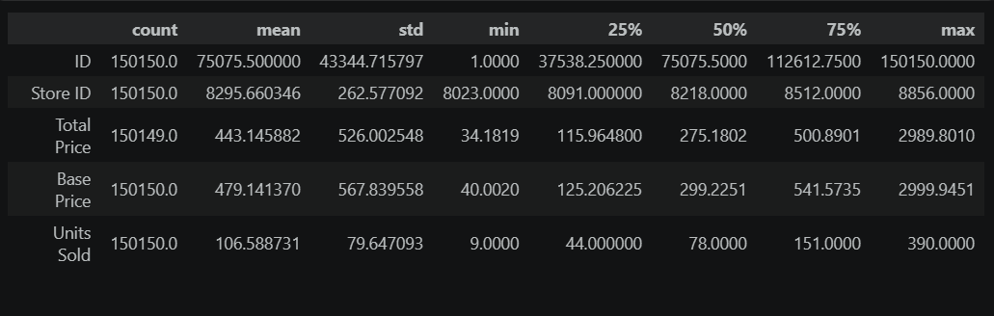
- Checking about the correlation between features in a dataset:

pd.DataFrame.corr() calculates the correlation between features pairwise excluding null
values.A correlation matrix is a table showing correlation coefficients between variables. Each cell in the table shows the correlation between two variables. A correlation matrix is used to summarize data, as an input into a more advanced analysis, and as a diagnostic for advanced analyses.
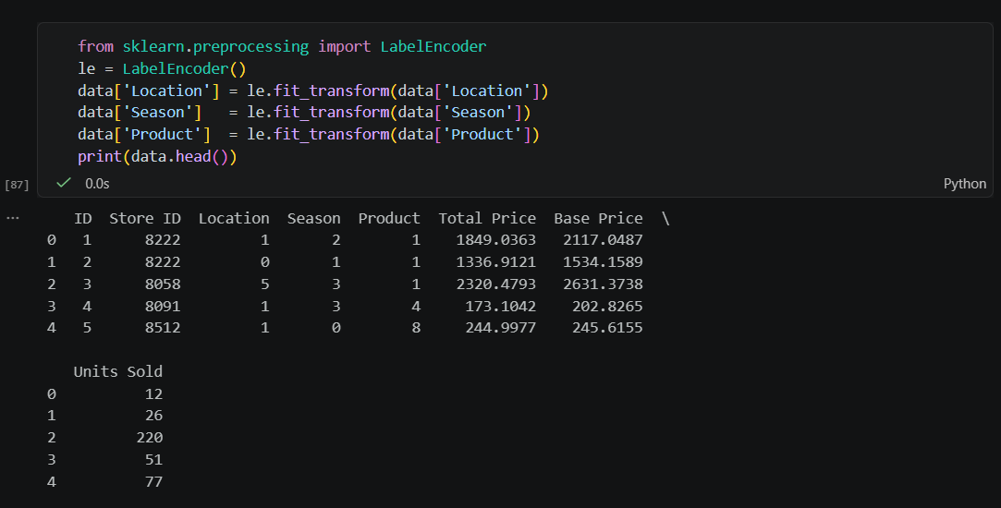
3.3 Analysis on Dataset:
- Checking about data types and more information about the data:

pd.dataFrame.info() which returns the data type of each column present in the dataset. It
tells about null and not null values present.

data.info()
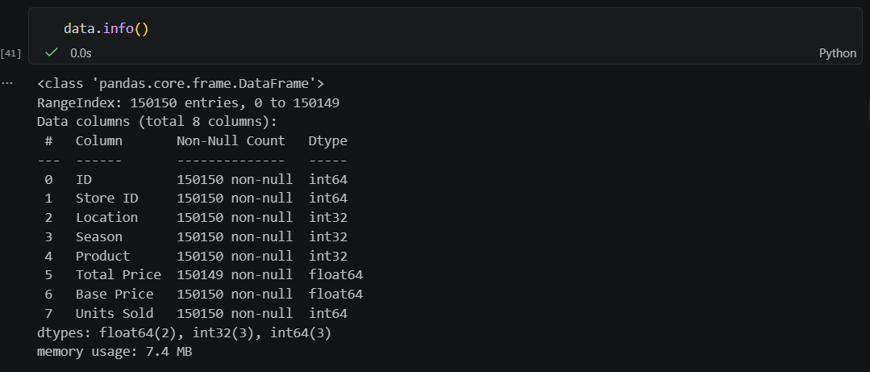

- Checking about missing values in the data:

Missing values in the data can be checked by using isnull() function present in pandas.

data.isnull().sum()

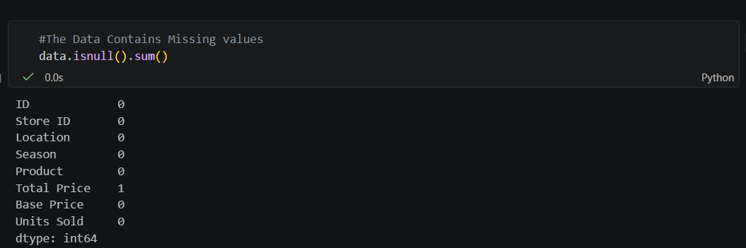

Printing the missing row:

S = pd.isnull(data['Total Price']) data[S]
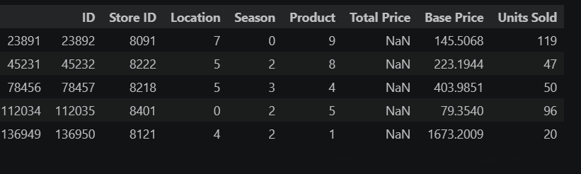
Visualize missing values (NaN) values using Missingno Library:

Missingno library offers a very nice way to visualize the distribution of NaN values. Missingno is a Python library and compatible with Pandas.
Matrix :
Matrix can quickly find the pattern of missingness in the dataset.
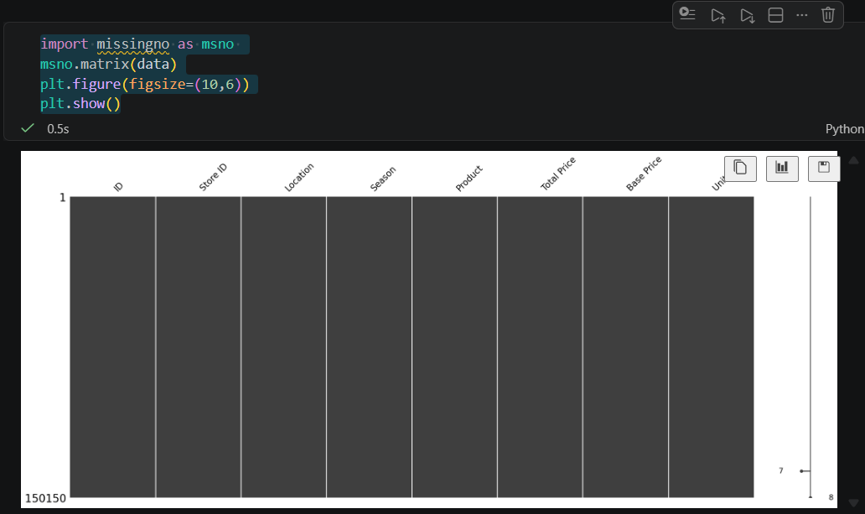

Bar Chart :

This bar chart gives you an idea about how many missing values are there in each column.
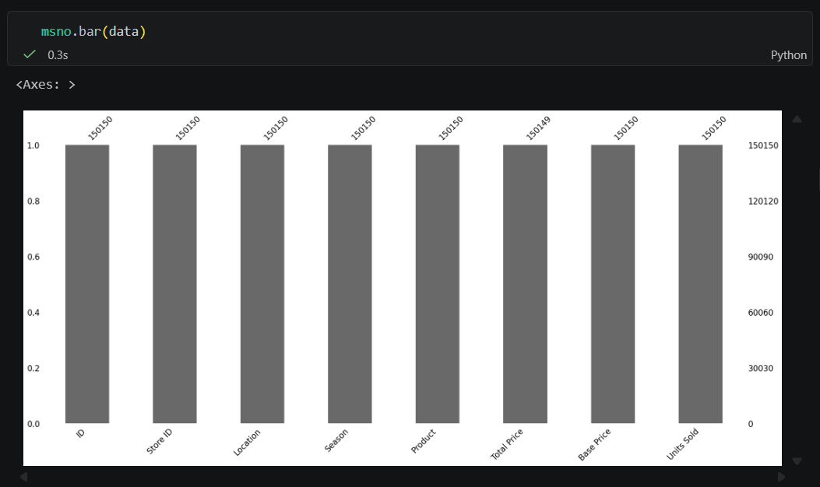
missingno.bar representation

3.4 Pre-Processing Data
Handling the missing data:
1.Dropping data:
dropna() function is used to remove missing values from the dataset.
data = data.dropna()
After removing the null values by checking the shape of the dataset, we come to know that one row has been removed.
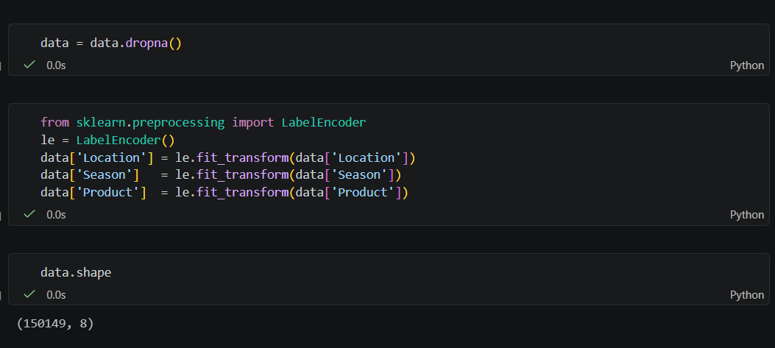
2.Replacing with an arbitrary value:
If we can make an educated guess about the missing value, then it can be replaced with
some arbitrary value.
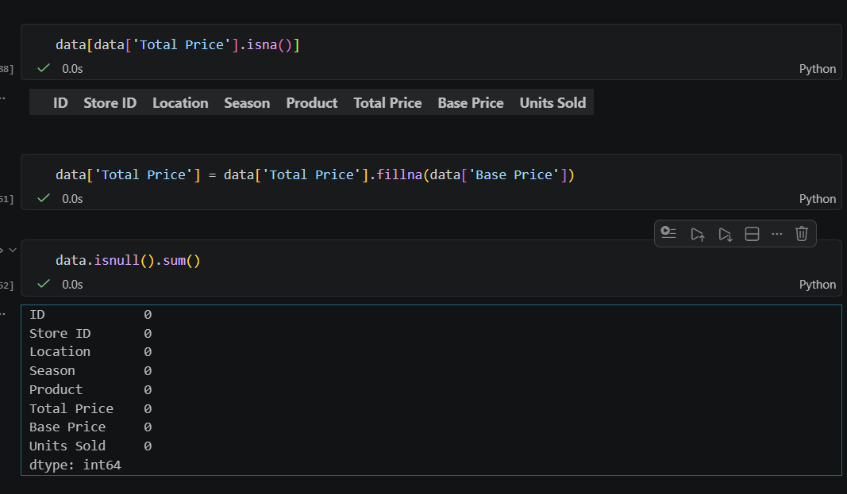
3.Replacing with the Mean:
This is the most common method of imputing missing values of numeric columns. If
there are outliers, then the mean will not be appropriate.

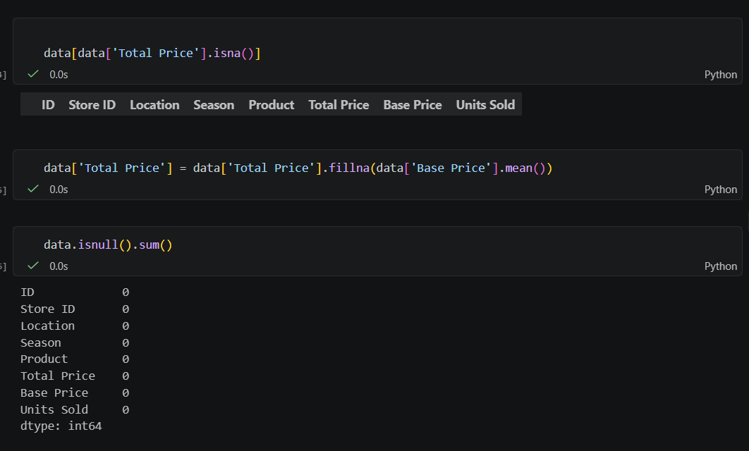 4.Replacing with the Mode:
Mode is the most frequently occurring value. It is used in the case of categorical features.

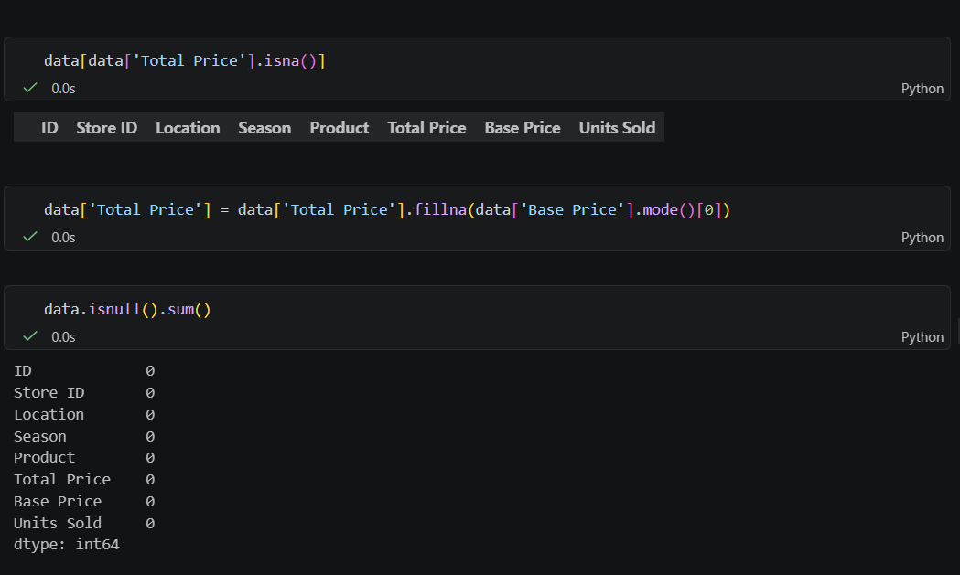
5.Replacing with the Median:
The median is the middlemost value. It’s better to use the median value for imputation in
the case of outliers.

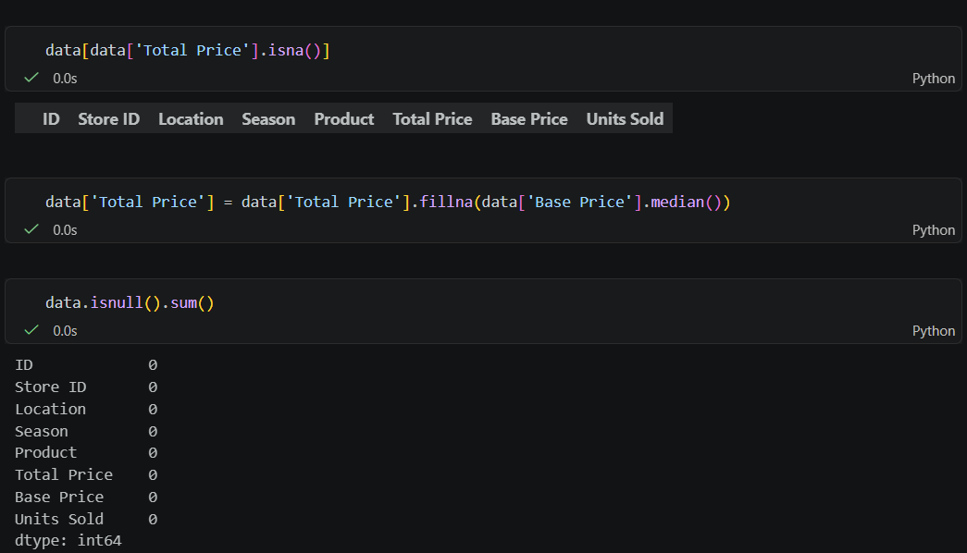
6.Replacing with the Previous value – forward fill:
In some cases, imputing the values with the previous value instead of the mean, mode, or
median is more appropriate. This is called forward fill. It is mostly used in time series data.
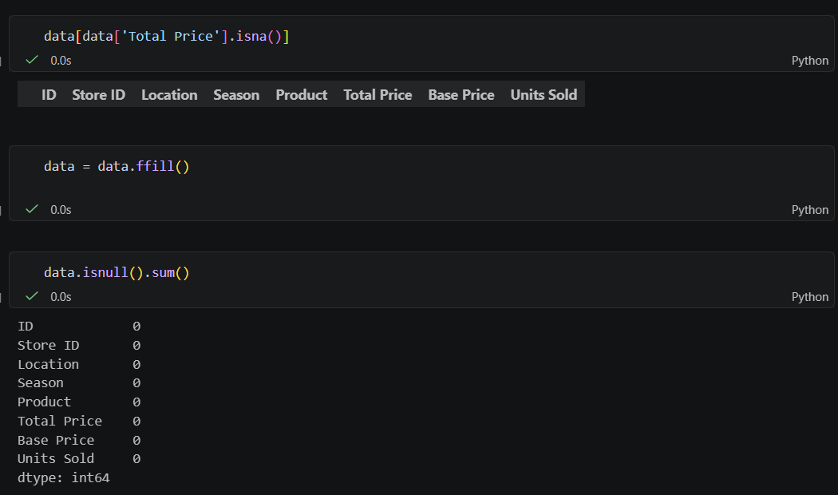
7.Replacing with the Next value – backward fill:
In backward fill, the missing value is imputed using the next value.
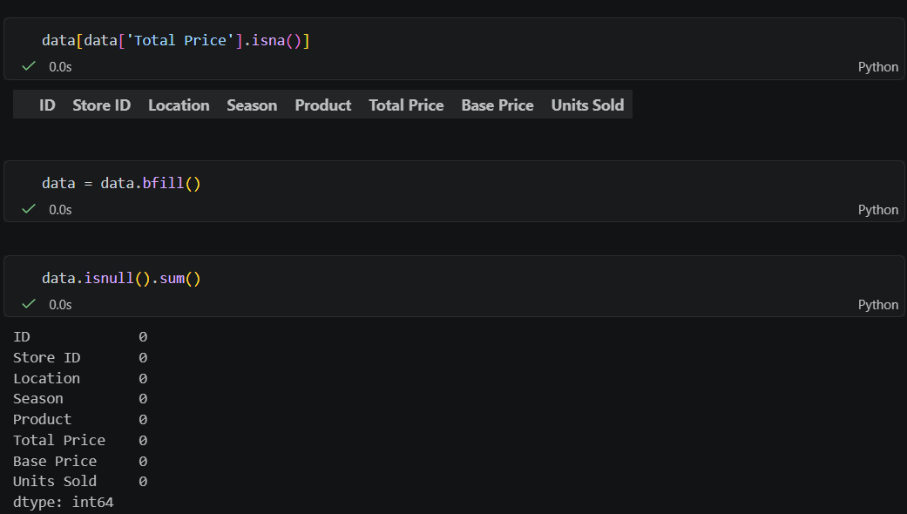
8.Interpolation:
Missing values can also be imputed using interpolation. Pandas’ interpolate method can
be used to replace the missing values with different interpolation methods like ‘polynomial,’ ‘linear,’ and ‘quadratic.’ The default method is ‘linear.’

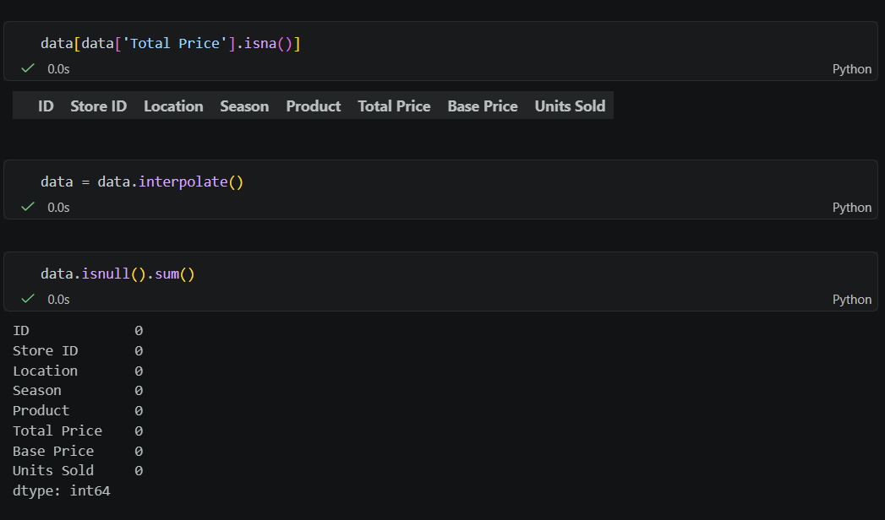
9.Multivariate Approach:
9.1 Iterative Imputer:
Iterative imputer is a machine learning-based method for imputing missing values
in a dataset by iteratively estimating missing values based on other observed features, refining predictions in multiple cycles.

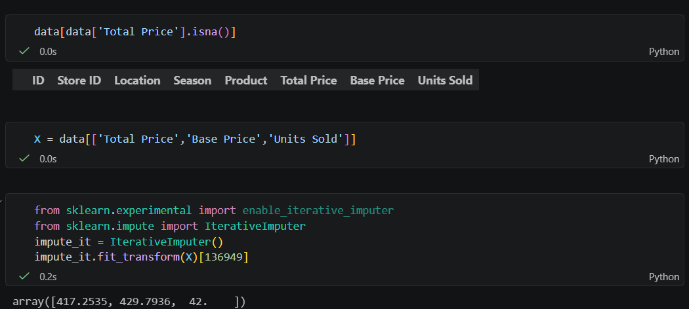
9.2 KNN Imputer:
Missing values are imputed using the k-Nearest Neighbours approach, where a Euclidean distance is used to find the nearest neighbours.
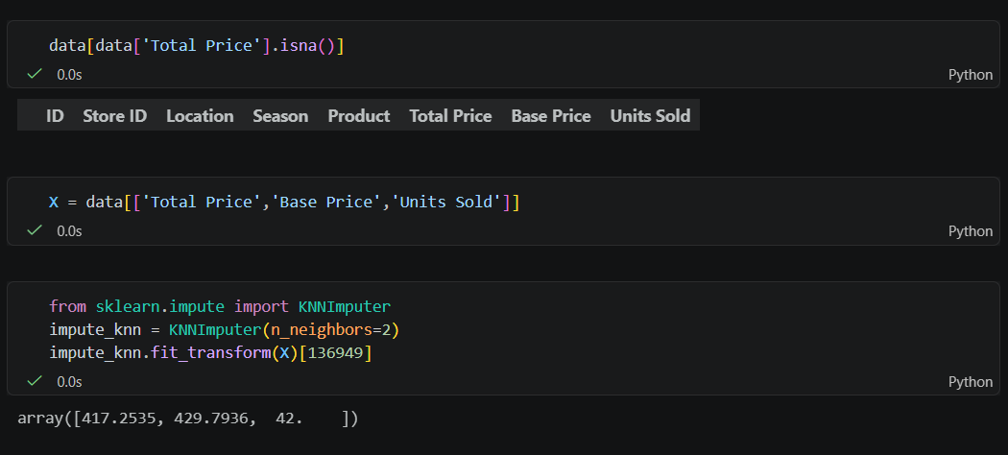

Feature Scaling:

Feature scaling is a data pre-processing technique used to transform the values of features
or variables in a dataset to a similar scale. The purpose is to ensure that all features contribute equally to the model and to avoid the domination of features with larger values.

Feature scaling becomes necessary when dealing with datasets containing features that
have different ranges, units of measurement, or orders of magnitude. In such cases, the variation in feature values can lead to biased model performance or difficulties during the learning process

There are several common techniques for feature scaling, including standardization,
normalization, and min-max scaling. These methods adjust the feature values while preserving their relative relationships and distributions.

Tree-based algorithms are fairly insensitive to the scale of the features.A decision tree
only splits a node based on a single feature. The decision tree splits a node on a feature that increases the homogeneity of the node. Other features do not influence this split on a feature.
So, the remaining features have virtually no effect on the split. This is what makes them
invariant to the scale of the features!

1. Normalization: Normalization is a scaling technique in which values are shifted and rescaled so that they end up ranging between 0 and 1. It is also known as Min-Max scaling.

Normalization Equation

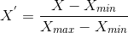

X_{max} and X_{min} are the maximum and the minimum values of the feature

2. Standardization: Standardization is another scaling method where the values are centered around the mean with a unit standard deviation.This means that the mean of the attribute becomes zero, and the resultant distribution has a unit standard deviation.

Standardization equation

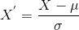

Normalization also helps to reduce the impact of outliers and improve the accuracy and stability of statistical models.
Standardization:
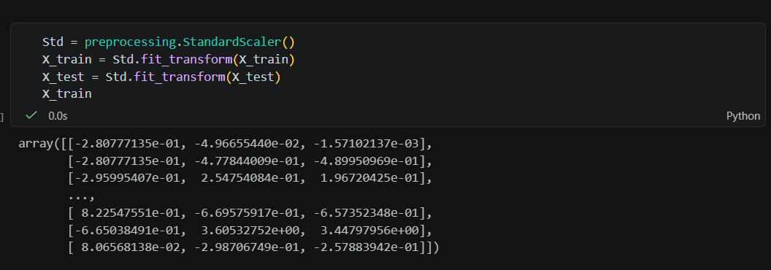 Normalization:

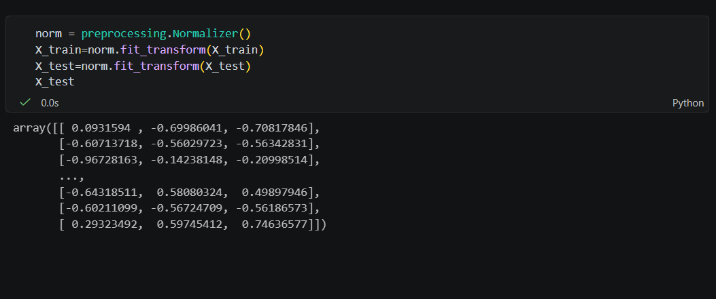

10. Histogram: Univariate Analysis
A Histogram shows how data values are distributed across the dataset. We used it to understand the distribution of Units Sold
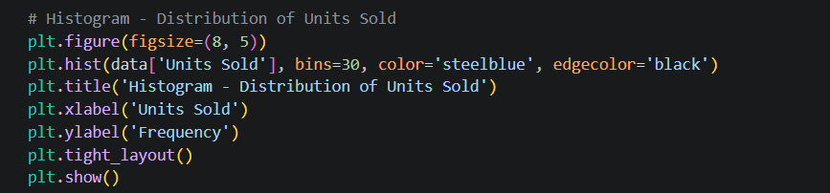
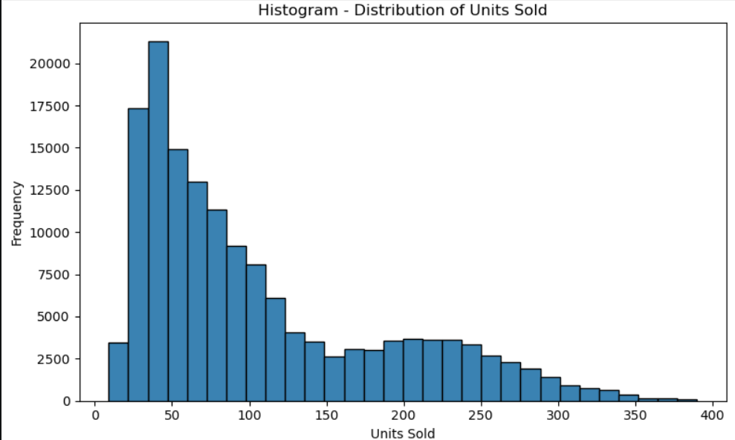

11. Box Plot: Bivariate Analysis (Units Sold by Season)
A Box Plot helps detect outliers and shows data spread. We plotted Units Sold by Season to understand demand variation across seasons

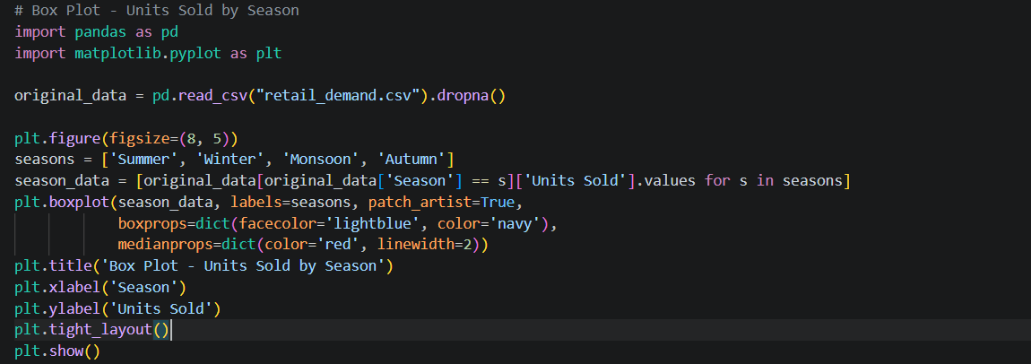
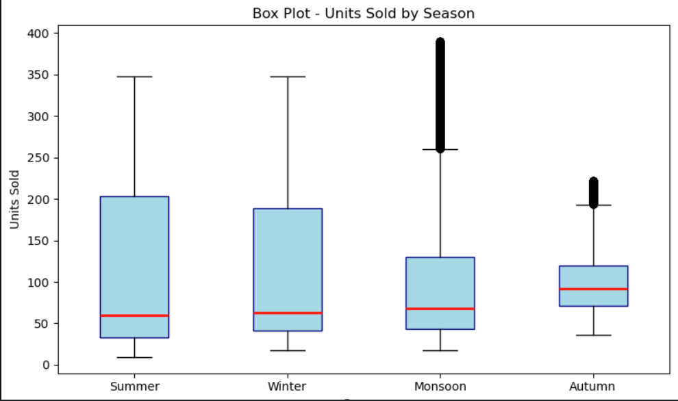

12. Bar Graph: Bivariate Analysis (Average Units Sold by Season)
A Bar Chart is used for categorical variables to compare average values. We plotted average Units Sold by Season.
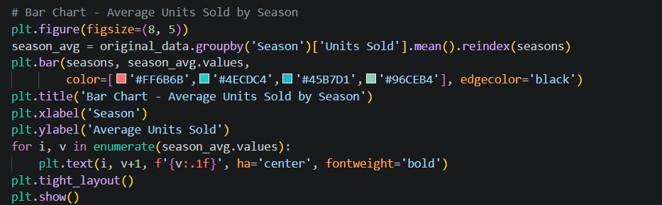
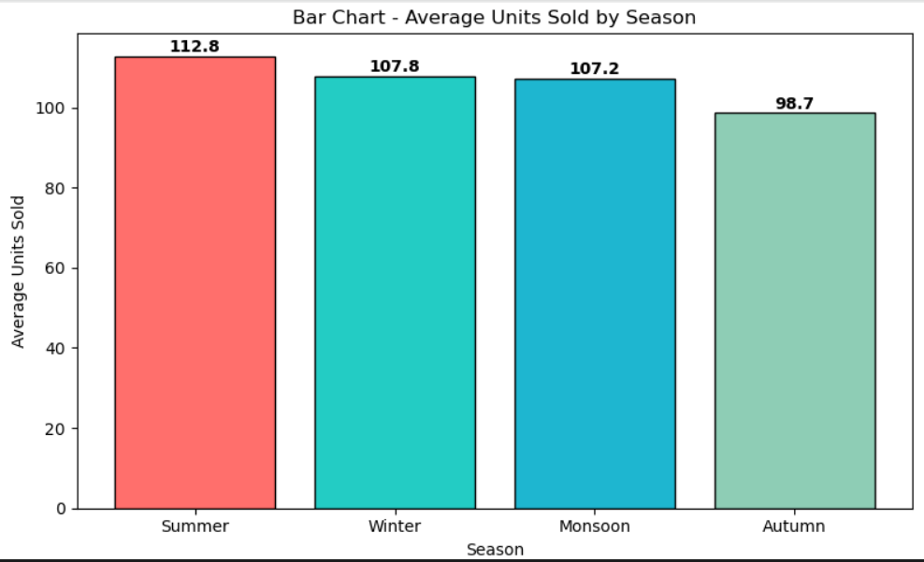
13. Line Graph: Multivariate Analysis (Units Sold by Season per Location)
A Line Graph compares variables across categories to identify trends. We plotted Units Sold trend across seasons for each of the 8 Indian cities.
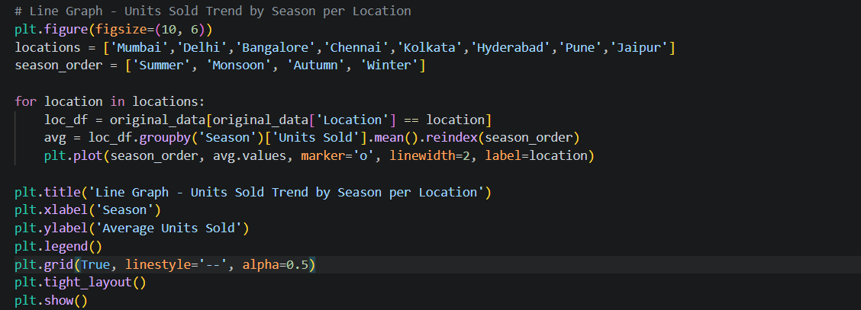
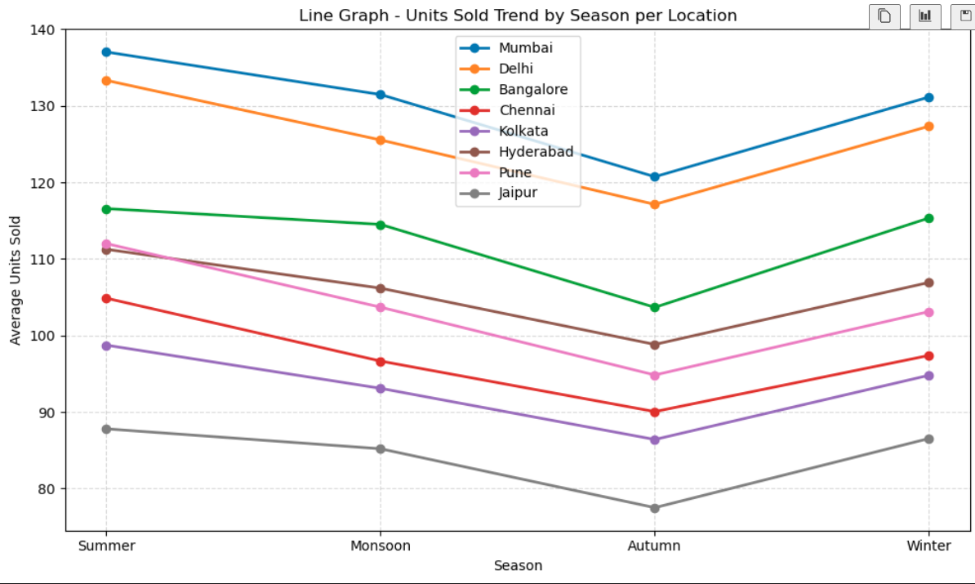
Does Random Forest Need Feature Scaling or Normalization?

Normalization and Standardization are not typically required for Random Forest models because Random Forest is an ensemble of decision trees that doesn't rely on the scale of features and is robust to outliers. Scaling features can potentially hinder the interpretability and computational efficiency of the model and may not provide any significant improvement in performance.

Conclusion:

In conclusion, the rigorous pre-processing of the dataset has rendered it well-suited for the subsequent stages of model development and analysis. We added Location and Season as key features and applied Label Encoding to convert categorical variables into numerical representations. Handling missing values and applying feature scaling techniques were pivotal steps in ensuring data quality and reliability for our retail demand prediction model.

